Dear Mr. Vijay RATE QUOTATION 1-Feb-26
Delhi

Greetings from Urban Cruise™!

With reference to your Enquiry, pls find the Trip details, Vehicle Options & Pricing-

YOUR TRAVEL REQUIREMENT
Travel  Detail | 9-Nov 6.30am | 27- Trimbakeshwar | 28- Nashik SS | 29- Nashik to Shirdi, Shirdi SS | 1 Mar- Shirdi to ShaniSignapur to Aurangabad | 2- Aurangabad SS | 3- Aurangabad to Mumbai A0050 |  |  |  | 9-Nov 8.30pm
 | Mumbai Airport |  |  |  |  | Mumbai Airport
Travel Date | 9-Nov to 9-Nov 2024  (7 days) |  | TRIP TYPE  Round Trip | PAX  17 | Remarks-

VEHICLE OPTIONS & PRICING
# | VEHICLE TYPE | No. of Veh. | DESCRIPTION |  |  | DISCOUNTED  PRICE
1 | 13 Seat | Force Traveller | 1 | ECONOMY- Basic A/c, Non-Recline Seat, Basic |  |  | Rs. 15,800
2 | 13 Seat | Force Traveller | 1 | PREMIUM- 2018-20 Model, A/c, Recline Seat, Charging Point, Music System + Speaker |  | IMAGE | Rs. 16,400
3 | 13 Seat | Force Traveller | 1 | ROYAL- 2021-23 Model, Modified Veh., Good A/c, Recline Seat, Charging Point, BT Music + Speaker, Sofa/Bed |  | IMAGE | Rs. 17,000
4 | 12 Seat | Force Traveller | 1 | ROYAL^{VIP}- A/c, 1x1 VIP Maharaja Seat, More Legroom, Custom Designed Veh., Charging Points, Personal A/c Vent, BT Touch Music + Good Speakers, HD TV |  | IMAGE | Rs. 21,200
5 | 15 Seat | Force Urbania | 1 | ROYAL^{VIP}- A/c, 2x1 Recline Seat (15), Comfortable & Silent Cabin, Panoramic Window, Charging Points, Personal A/c Vents, BT Music + Speaker, Comfort, Silent Cabin |  | IMAGE | Rs. 30,000
- Above pricing include Vehicle Cost, Fuel, Driver, Tax. | A/C will be Switched OFF intermittently on Hills.
- KM will be counted from Pickup Point to Pickup Point | Visit to Local Delhi Places is not included in cost.
- There are some places in Hills where Veh. may not go due to Restrictions by Local Govt.
SPECIAL OFFER Discount of Rs. 2000/- already applied in above price. This Price Offer is valid till 9-Nov
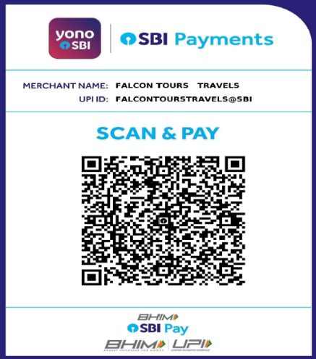


89289 46056

A/c Name- Urban Cabs | AXIS Bank
A/c No. - 922020012721497
IFSC Code- UTIB0000572
SCAN & PAY
urbancruise@axisbank

- Toll Charges  Already included in the Cost.
- Parking & Police Entry NOT Included. Client will Pay to Driver.
- Extra Charge above 1800 kmRs. 20/km (1-3) | Rs. 26/km (4) | Rs. 40/km (5)
- Extra Charge (Local) above N / ARs. 20/km | Rs. 150/hr
- Driver Night charge Before 6am (1st Day) & after 11pm (Last Day)- Rs. 500 |
After 1 am- Rs. 500/Hr. | After 3 am- Next Day Full Charge

OTHER CHARGEs (if applicable) -

